Name: Class:
Introduction
The following formulas are useful when completing calculations involving solutions and gases.

Formula | What it means
n = 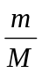 | Amount (mol) = 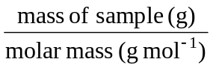
n = 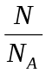 | Amount (mol) = 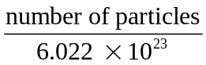
n = c × V | For solutions  Amount (mol) = concentration (mol L^{–1}) × volume (L)
pV = nRT  and  pV = 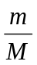RT | For gases  Pressure (kPa) × volume (L)  = amount (mol) × gas constant (8.314 J K^{–1} mol^{–1}) × temperature (K)
n = 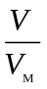 | For gases at standard temperatures and pressures  Amount (mol) = 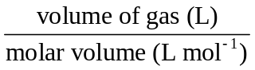  where molar volume, VM, is  22.4 L mol^{–1} at STP (0°C and 101.3 kPa)  24.5 L mol^{–1} at SLC (25°C and 101.3 kPa)
D = | Density =  (unit of density depends on the units of mass and volume)
For dilution of a solution: c₁ × V₁ = c₂ × V₂
where c₁ = initial concentration, v₁ = initial volume, c₂ = final concentration, v₂ = final volume.

Unit of concentration | What it means
% m/m | Mass of solute (in g) in 100 g of solution
% m/v | Mass of solute (in g) in 100 mL of solution
% v/v | Volume of solute (in mL) in 100 mL of solution
ppm | Mass of solute (in g) in 10⁶ g of solution  or mass of solute in mg in 1 kg of solution

No. | Question | Answer
a What amount (in mol) of oxygen is present in 5.00 g of glucose, C₆H₁₂O₆?
b How many atoms are present in 8.36 g of hydrogen peroxide, H₂O₂?
 | What volume of water should be added to 35.0 mL of 0.300 mol L^{–1} H₂SO₄ in order to produce a 0.0900 mol L^{–1} solution?
 | What pressure does 0.49 mol of SO₃ exert in a sealed 3.0 L vessel at 54ºC?
 | The heaviest known atom has a mass of about 4 × 10^{–22} g. What would be the mass of one mole of these atoms?
 | What volume will 62.0 g of carbon dioxide gas occupy at a temperature of 124°C and 210 kPa?
 | What volume of water must be added to 1.00 L of a solution containing 70.2 g of NaCl to produce a solution of 0.670 mol L^{–1} NaCl?
 | 2.06 g of a hydrocarbon occupies 16 L at 27ºC and 20 kPa. Find the molar mass of this compound, and so identify the hydrocarbon.
What mass of ammonia is present in
150 mL of the 1.50% m/v solution?

 | 0.778 g of one of the halogens (group 17) was found to occupy a volume of 122 mL at a pressure of 99 800 Pa and a temperature of 26°C. Which halogen was it?
A sample of water from a waterway is found to contain 600 ppm mercury. How many atoms of mercury would be in
100 g of the water?
 | 3.5 g of Pb(NO₃)₂ is added to 60 mL of distilled water in a beaker and stirred to dissolve the solid. 10 mL of this solution is then transferred to another beaker and mixed with 20 mL of distilled water. What are the concentrations (in mol L^{–1}) of these two solutions?
 | 50 mL of a 16% m/v silver nitrate solution is added to an equal volume of distilled water. What is the concentration of the dilute solution in ppm?
A solution of silver nitrate (AgNO₃) is made by dissolving 2.33 g of solid in 398 mL of distilled water. What is the concentration of this solution in:
a % m/v?
b M?

